Applecart Arts  Art Centre  170 Harold Road  E13 0SE | 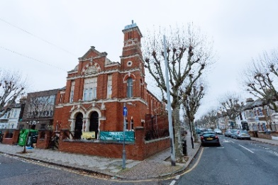 | March 8th  April 5th  May 3rd  June 7th  July 5th | 10:00 -13:00
Canning Town Library  Rathbone Market  18 Barking road  Canning Town  E16 1EH | 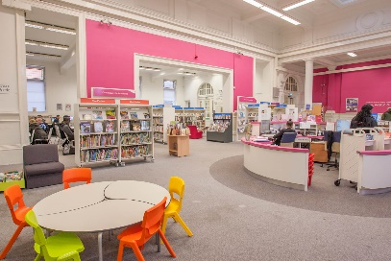 | March 28th*  April 25th*  May 23^{rd*}  June 27th*  July 25th* | 10:00 -13:00
Durning Hall Community Centre – Earlham Grove  Forest Gate  E7 9AB | 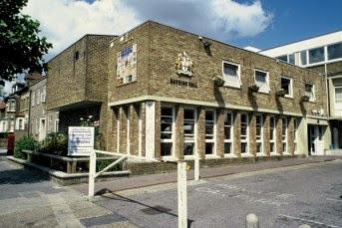 | March 7th  April 4th  May 2nd  June 6th  July 4th | 10:00 -13:00
Froud Centre  1 Toronto Avenue  Manor Park  E12 5JF | 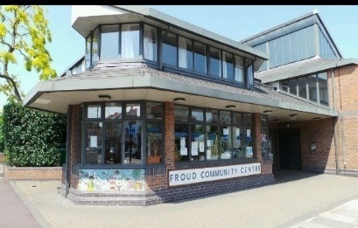 | March 22nd  April 19th  May 17th  June 21st  July 19th | 10:00 -13:00
Saint Marks Church & Community Centre  218 Tollgate Road  E6 5YA |  | March 15th  April 12th  May 10th  June 14th  July 12th | 10:00 -13:00
The Stratford Advice Arcade  107-109 The Grove  E15 1HP | 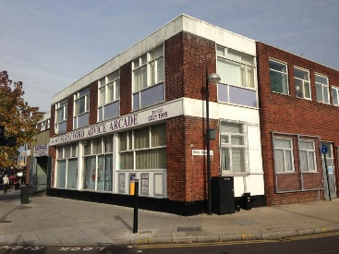 | March 14th  April 11th  May 9th  June 13th  July 11th | 10:00 -13:00
Trinity Centre  East Avenue  Newham  E12 6SG | 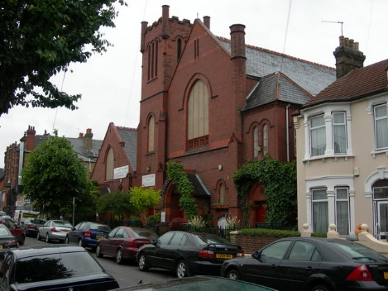 | March 1st  April 26th  May 24th  June 28th  July 26th | 10:00 -13:00
Well Community Centre,  49 Vicarage Lane  Newham  East Ham  E6 6DQ | 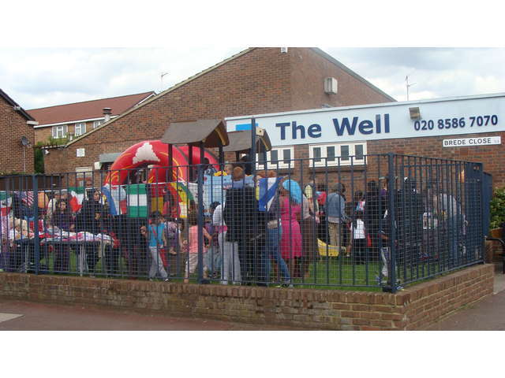 | March 21st  April 18th  May 16th  June 20th  July 18th | 10:30 -13:30

